**MD. MIZANUR RAHMAN**

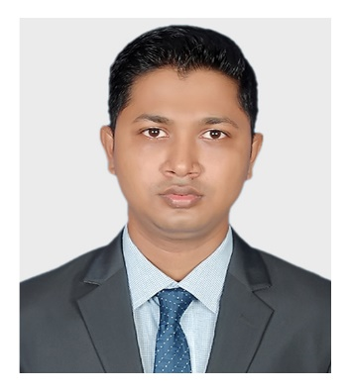

**Mailing Address**

Address: 257-258 (5th floor), Rose Elegance,

Ibrahimpur Primary School Road, Ibrahimpur, Kafrul, Dhaka-1206.

Phone: 01680225343

Email: [themizan404@gmail.com](mailto:themizan404@gmail.com)

LinkedIn: [linkedin.com/in/themizan404](https://www.linkedin.com/in/themizan404/)

Github: [github.com/themizan404](https://github.com/themizan404)

Looking for a challenging role in a reputable organization to utilize my technical, database, and management skills for the growth of the organization as well as to enhance my knowledge about new and emerging trends in the IT sector.

**Training**

Enterprise System Analysis & Design – JEE

(Under Supervision of IsDB-BISEW IT Scholarship Programme)

**Education**

|  |  |  |  |  |
| --- | --- | --- | --- | --- |
| **Examination** | **Institute** | **Subject/Group** | **Result** | **Year** |
| MSS (Master) | University of Dhaka | Economics | Appeared |  |
| BSS (Honor) | University of Dhaka | Economics | 2.99 out of 4.00 | 2018 |
| HSC | Adamjee Cantonment College | Humanities | 4.60 out of 5.00 | 2011 |
| SSC | Uttar Kafrul High School | Humanities | 4.06 out of 5.00 | 2009 |

**Skills**

Languages : Java, SQL, JavaScript, TypeScript, XML, CSS, HTML, UML

Frameworks : Spring, JSF, Angular 6, Swing, Hibernate

Mobile OS : Android

Libraries : JQuery, ReactJs, Bootstrap

Database : MySQL, Oracle, SQLite3, Firebase

Web Design : Html, CSS

VCS : Git, Github

Servers : Apache Tomcat, NodeJs, GlassFish

Concepts : Digital Marketing

IDE tools : NetBeans, Eclipse

UX/UI : Photoshop, Illustrator, Premiere Pro

**Projects**

Hospital Management & Information System

* Technologies Used: Java, Spring, Tomcat, Hibernate, MySQL, Jquery, Bootstrap
* Link: [github.com/themizan404/SpringProject](https://github.com/mizan404/SpringProject)

E-Voting Management System

* Technologies Used: Java, Swing, MySQL
* Link: [github.com/themizan404/All-Swing/tree/master/vote_management](https://github.com/themizan404/All-Swing/tree/master/vote_management)

Blood Bank Application

* Technologies Used: Java, Android Studio, MySQL, PHP(Server)
* Link: [github.com/themizan404/Android-main/tree/main/Project](https://github.com/themizan404/Android-main/tree/main/Project)

**Certification**

* <https://www.sololearn.com/Certificate/1068-19137256/pdf/>
* <https://olympus1.greatlearning.in/course_certificate/HNVEPBML>

**Personal Info**

Father’s Name : Md. Babar Ali

Mother’s Name : Sultana Parvin

Date of Birth : 16th November, 1994

Gender : Male

Religion : Islam

Nationality : Bangladeshi

Marital Status : Single

NID : 5550086796

Permanent Address : Pachani, Alaipur (9240), Rupsha, Khulna.

**Language Proficiency**

Bengali : Native speaker

English : Professional working efficiency

**References**

|  |  |
| --- | --- |
| Moshaidul Islam  IsDB-BISEW, Consultant of IsDB-BISEW  01711071219  [moshaidul@gmail.com](mailto:moshaidul@gmail.com) | Muhammad Maruf Hasan  IsDB-BISEW, Instructor of IsDB-BISEW  01825970006  [maruf.tcl@gmail.com](mailto:maruf.tcl@gmail.com) |



**Signature**